**FACE MASK RECOGNITION SYSTEM**

**Sourav Pusti**

**Niket Ranjan**

**Chirasree Roy**

**Moupia Roy**

Under the guidance of

**Prof. Sumani Chakroborty**



**Mini Project** / **Electronic Design Workshop (EC681)**

**Department of Electronics and Communication Engineering**

**St. Thomas’ College of Engineering and Technology**

4, D. H. Road, Kolkata 700023

June, 2022

# Vision of the Department

• To build a strong teaching and research environment to cater to the manpower needs in Industrial and Academic domains of the rapidly growing Electronics and Communication Engineering.

# Mission of the Department

* To produce certified industry-ready professional in Electronics and Communication Engineering, though innovative educational programs in corporating laboratory practices and project-based teaching-learning processes, in a modern environment.
* To create knowledge base of advanced technologies through research in the area of Electronics and Communication, for competitive and sustainable development of the country.
* To groom the department as a learning centre to inculcate advancement of technology in Electronics and Communication Engineering with social values and environmental awareness.

# Program Specific Outcome (PSOs)

After completion of program, graduate engineer would have:

* **PSO1. Professional Skills:** An ability to apply the knowledge in Electronics and Communication Engineering in various areas, like Communications, Signal processing, VLSI and Embedded Systems.
* **PSO2. Competency:** An ability to qualify at the State, National and International level competitive examinations for employment, higher studies and research .

**PROGRAMOUTCOMES(POs)**

**Engineering Graduates will be able to:**

1. **Engineering knowledge**: Apply the knowledge of mathematics, science, engineering fundamentals, and an engineering specialization to the solution of complex engineering problems.
2. **Problem analysis**: Identify, formulate, review research literature, and analyze complex engineering problems reaching substantiated conclusions using first principles of mathematics, natural sciences, and engineering sciences.
3. **Design/development of solutions**: Design solutions for complex engineering problems and design system components or processes that meet the specified needs with appropriate consideration for the public health and safety, and the cultural, societal, and environmental considerations.
4. **Conduct investigations of complex problems:** Use research-based knowledge and research methods including design of experiments, analysis and interpretation of data, and synthesis of the information to provide valid conclusions.
5. **Modern tool usage**: Create, select, and apply appropriate techniques, resources, and modern engineering and IT tools including prediction and modeling to complex engineering activities with an understanding of the limitations.
6. **The engineer and society**: Apply reasoning informed by the contextual knowledge to assess societal, health, safety, legal and cultural issues and the consequent responsibilities relevant to the professional engineering practice.
7. **Environment and sustainability**: understand the impact of the professional engineering solutions in societal and environmental contexts, demonstrate the knowledge of, and need for sustainable development.
8. **Ethics**: Apply ethical principles and commit to professional ethics, responsibilities, and norms of the engineering practice.
9. **Individual and teamwork**: Function effectively as an individual, and as a member or leader in diverse teams, and in multidisciplinary settings.
10. **Communication**: Communicate effectively on complex engineering activities with the engineering community and with society at large, such as, being able to comprehend and write effective reports and design documentation, make effective presentations, and give and receive clear instructions.
11. **Project management and finance**: Demonstrate knowledge and understanding of the engineering and management principles and apply these to one’s own work, as a member and leader in a team, to manage projects and in multidisciplinary environments.
12. **Life-long learning:** Recognize the need for, and have the preparation and ability to engage in independent and life-long learning in the broadest context of technological change.

# Course Outcomes

**After completion of the project, student will be able to:**

|  |  |  |
| --- | --- | --- |
| **Outcome no.** | **Outcome Statements** | **Bloom’s Level** |
| CO1 | Conceive a problem statement either from rigorous literature survey or from the requirements raised from need analysis | 5 |
| CO2 | Design, implement and test the prototype/algorithm in an innovative way to solve the complex engineering problems | 6 |
| CO3 | Apply technical knowledge in the solution of complex real-life problems | 3 |
| CO4 | Write comprehensive report on any project work | 6 |
| CO5 | Understand the impact of the suggested solutions in health, society, cost etc | 2 |
| CO6 | Apply the knowledge acquired during the project, in future higher studies or any professional job | 3 |

**Bloom’s Level:**

**Remember=1; Understand=2; Apply=3; Analyze=4; Evaluate =5; Create=6**

**Project Outcomes Vs Program Outcome and Program Specific Outcome (PO) Matrix:**

PO1

PO2

PO3

PO4

PO5

PO6

PO7

PO8

PO9

PO10

PO11

PO12

PSO1

PSO2

CO1

CO2

CO3

CO4

CO5

CO6

# CertifiCate

Department of Electronics and Communication Engineering

**St. Thomas’ College of Engineering and Technology**

This is to certify that the Mini Project/ Electronic Design Workshop titled “FACE MASK RECOGNITION SYSTEM” has been carried out under my/our guidance.

Sourav Pusti (49)

Niket Ranjan

(50)

Chirasree Roy (51)

Moupia Roy (52)

Dated: 03/06/2022

……………………………………………….

Sumani Chakroborty

(Project guide)

## Acknowledgement

**Sourav Pusti**

**Niket Ranjan**

**Chirasree Roy**

**Moupia Roy**

Dated: 03/06/2022

## Contents

**Chapter No. Chapter Name Page No.**

1. **Introduction 8-9**

(<Project Abstraction, Introduction, Motivation, Problem Statement Objectives and Applications>)

1. **Background of the Project 10-11**

(<Including Literature Survey , Recent Work, and Summary>)

1. **Details of the Project 12-23**

(<Block Diagrams/ Flow chart/Circuit

Diagram/Layout Diagrams/Component List/ Algorithms>)

1. **Results 23-24**

(<Tables/Graphs/Photographs/Results Analysis>)

1. **Comments on the results 24**
2. **Conclusion 25**

(Including Discussion & Future Works)

1. **Reference 26**

## INTRODUCTION

**1.1 ABSTRACT**

Coronavirus has spread all around the world now and it has impacted all areas. The medical care arrangement of practically every nation is going through emergency. Many advances had taken to lessen the spread of Coronavirus where wearing a veil is one of them. In this Project, we have proposed a framework which will assist with decreasing the spread of covid19 at Grocery Shop which further can be carried out at Malls, Universities, Smart Urban communities and so forth through CCTV Cameras by recognizing individuals who are not wearing a veil. We trust this framework will assist with lessening the spread of Covid-19 in some content by illuminating to the proprietor of Grocery shop about the speculated individual.

**1.2 INTRODUCTION**

We are managing COVID-19 from most recent 2 years and it can get transmitted through air. In this way, to keep away from the immediate contact at public premises we are working on IOT Based framework which can distinguish mask and assuming any issue appears, automatically it will send data of that individual to the proprietor or particular authorities and if it will detect mask then it will grant the access other access will be denied. The principle center is to recognize faces, not to distinguish or check it also detecting whether or not the individual is wearing cover. Since these scenarios become vital to follow since the Covid19.and still we really want to follow these principles in light of the fact that Covid-19 isn't absolutely under control. In future also we should be prepared for these sort of pandemics. Likewise for safeguarding us from Virus we want to observe the guidelines. We really want to check whether or not the individual wearing a mass. Along these lines, we can handle the transmission of infections or any viral illnesses which communicates through air. Today CCTV's are utilized in many public and private regions for reconnaissance exercises we can utilize them to enforce the rules like wearing cover.

**1.3 MOTIVATION**

Coronavirus is an overpowering contamination brought about by a recently discovered Corona virus. One of the least demanding method for controlling transmission is by providing basic instruction about the COVID-19 contamination, the ailment it causes and the way it spreads. The reason for this venture to make individuals mindful that wearing a cover is fundamental for their own and other's wellbeing and one having high temperature ought not meander outside to stop the spread of virus. The proposed project carry out IoT-put together system with respect to COVID-19 monitoring at Grocery Shop has end to make individuals mindful that face covers are fundamental for their own and other's security and one having high temperature ought not wander outside to stop the spread of infection. So, following the principles is exceptionally essential. For that - Checking whether each one is wearing a veil. - Checking Temperature of assemblage of everybody who is entering. - Checking everybody is keeping social separation. The motivation of this task came from looking a large portion of individuals disobeying the decides guidelines that are obligatory to stop the spread of Covid.

**1.4 PROBLEM STATEMENT**

The impacts of COVID-19 on the worldwide economy should be visible with the naked eye, as the control of individuals in the homes carries with one that keeps on being experienced, it is applicable to put individuals' wellbeing before any useful action. That is why biosecurity measures and social separating conventions have been implemented to limit the spread of this perilous infection. As well as the limit in public institutions, businesses and different foundations has been restricted, highlighting the alleged telecommuting (in specific cases). In this manner, organizations have implemented various philosophies, procedures, and methods to safeguard the honesty and health, both while entering and remaining in up close and personal work meetings. As previously referenced, CNN have been a significant mechanical device during this pandemic. Albeit most methodologies have been taken towards the diagnosis of the infection, observing and anticipation has likewise been covered.

**1.5 OBJECTIVE AND APPLICATIONS**

Face mask detection refers to detect whether a person is wearing a mask or not. In fact, the

Problem is reverse engineering of face detection where the face is detected using different machine learning algorithms for the purpose of security, authentication and surveillance.

As per available literature, very little body of research is attempted to detect mask over face. Thus, our work aims to a develop technique that can accurately detect mask over the face in public areas (such as airports. railway stations, crowded markets, bus stops, etc.) to curtail the spread of Coronavirus and thereby contributing to public healthcare.

**BACKGROUND OF THE PROJECT**

**2.1 An Automated System to Limit COVID-19 Using Facial Mask Detection in Smart City Network [1]:**

COVID-19 pandemic caused by novel coronavirus is continuously spreading until now all over the world. The impact of COVID-19 has been fallen on almost all sectors of development. The healthcare system is going through a crisis. Many precautionary measures have been taken to reduce the spread of this disease where wearing a mask is one of them. In this paper, we propose a system that restrict the growth of COVID-19 by finding out people who are not wearing any facial mask in a smart city network where all the public places are monitored with Closed-Circuit Television (CCTV) cameras. While a person without a mask is detected, the corresponding authority is informed through the city network. A deep learning architecture is trained on a dataset that consists of images of people with and without masks collected from various sources. The trained architecture achieved 98.7% accuracy on distinguishing people with and without a facial mask for previously unseen test data. It is hoped that our study would be a useful tool to reduce the spread of this communicable disease for many countries in the world.

**2.2 Masked Face Recognition Using Convolutional Neural Network [2]:**

Recognition from faces is a popular and significant technology in recent years. Face alterations and the presence of different masks make it too much challenging. In the real-world, when a person is uncooperative with the systems such as in video surveillance then masking is further common scenarios. For these masks, current face recognition performance degrades. An abundant number of researches work has been performed for recognizing faces under different conditions like changing pose or illumination, degraded images, etc. Still, difficulties created by masks are usually disregarded. The primary concern to this work is about facial masks, and especially to enhance the recognition accuracy of different masked faces. A feasible approach has been proposed that consists of first detecting the facial regions. The occluded face detection problem has been approached using Multi-Task Cascaded Convolutional Neural Network (MTCNN). Then facial features extraction is performed using the Google Face Net embedding model.

**2.3 Some Recent Work:**

Samuel Ady Sanjaya and Suryo Adi Rakhmawan developed in Face Mask Detection Using

MobileNetV2. In the paper, a machine learning is used for face mask identification. The steps for building the model are collecting the data, pre-processing, splitting the data, 5 testing the model, and implementing the model. The proposed model can achieve an accuracy of 96.85%.

G. Jignesh Chowdary, Narinder Singh Puny, Sanjay Kumar Sonbhadra and Sonali Agarwal developed a system in Face Mask Detection using Transfer Learning of InceptionV3. In the paper, a transfer learning model is proposed to automate the process of identifying the people who are not wearing masks. The model uses deep learning algorithm Inception V3 to detect face masks. The Simulated Masked Face Dataset is used for training and testing. Due to the limited availability, image augmentation technique is used for better training and testing of the model. The model achieved an accuracy of 99.9% during training and 100% during testing.

Chhaya Gupta and Nasib Singh Gill proposed a system of Corona mask: A Face Mask Detector for Real-Time Data. Convolutional Neural Network (CNN) algorithm is used in this project to erect faces. In this paper, a dataset has been created which consists of 1238 images which are divided into two classes as “mask” and “no mask”. Live streaming videos can also be used as input and people wearing a mask and not wearing a mask can be detected. The convolutional neural network is trained on the dataset and it gives 95% of accuracy.

Sujatha and Chatterjee proposed a model that could be useful to foresee the spread of COVID2019 by using linear regression, Multilayer perceptron and Vector auto regression model on the COVID-19 kaggle data to envision the epidemiological example of the malady and pace of COVID-2019 cases in India.

A system that restrict the growth of COVID-19 by finding out people who are not wearing any facial mask in a smart city network where all the public places are monitored with ClosedCircuit Television (CCTV) cameras. Firstly, CCTV cameras are used to capture real-time video footage of different public places in the city. From that video footage, facial images are extracted and these images are used to identify the mask on the face.

**2.4 Summary of the Survey**

In the rise of Covid-19 cases all over the world, it is mandatory to follow the guidelines provided by WHO and local health authorities. The above cited paper were useful in visualization and understanding the flow of the entire project and also designing of its architecture, input and its format to be given for each module along with expected output were identified. The above cited papers are focused at one point in detecting people not wearing a mask. With reference to all these papers, our project is also focused on detecting people not wearing a face mask using ML Algorithm.

**DETAILS OF THE PROJECT**

**3.1 PROPOSED SYSTEM**

In the proposed system it consists of two parts, first one is software part another is

The hardware part. First one is the face mask detection i.e, is software part done

Using python libraries: Tensor flow, Keras, Open CV, Sklearn, Numpy, & OS.

Now, second part is hardware part where we have used Arduino & servo motor.

This model will work for two kind of person first one they wear the face mask & second

One is not wear the mask. In both of cases our model will work some operations.

1. First case it will detect our mask using ML Model & then it will grant access to user to enter.
2. Second case if model detect person is not wearing the mask, then the access will deny the user to enter.

The model we have used in the MobileNetV2 of convolutional neural network. The method of using MobileNetV2 is called using Transfer Learning. Transfer learning is using some pre trained model to train your present model and get the prediction which saves time and makes using training the different models easy. We tune the model with the hyper parameters: learning rate, number of epochs and batch size. The model is trained with a dataset of images with two class, with mask and without mask. The dataset has 2,416 images of with mask class and 2,418 images of without mask class:

1. **Training the model :**

Here we’ll focus on loading our face mask detection dataset from disk, training a model (using Keras/Tensor Flow) on this dataset, and then serializing the face mask detector to disk

1. **Deploying the model:**

Once the face mask detector is trained, we can then move on to loading the mask detector, performing face detection, and then classifying each face as with mask or without mask.

In the paper we have developed a model using the above mentioned libraries. We have tested the model for different conditions with different hyper parameters, for which the results are mentioned in the next section. First we feed the dataset in the model, run the training program, which trains the model on the given dataset. Then we run the detection program, which turns on the video stream, captures the frames continuously from the video stream with an anchor box using object detection process. This is passed through the MobileNetV2 model layers which classifies the image as with or without mask. If the person is wearing a mask, a green anchor box is displayed and red if not wearing a mask with the accuracy for the same tagged on the anchor box.

**3.2 FLOW CHART**

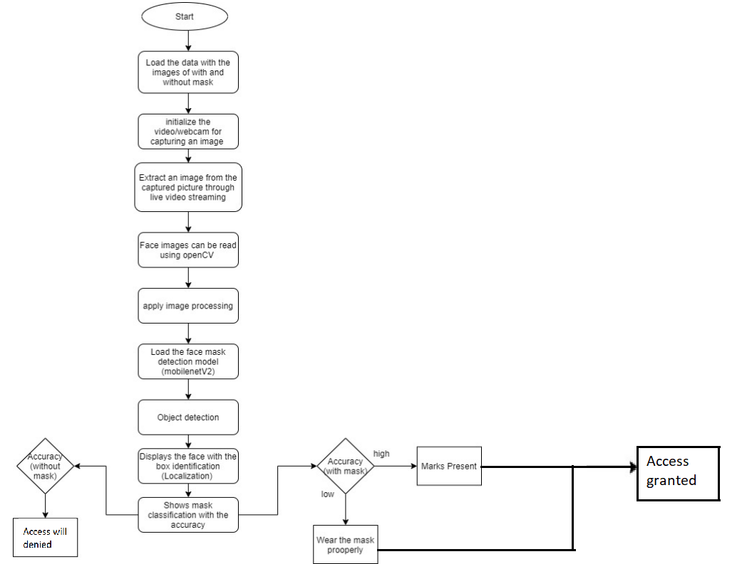

**3.3 MASK DETECTOR MODEL  
  
 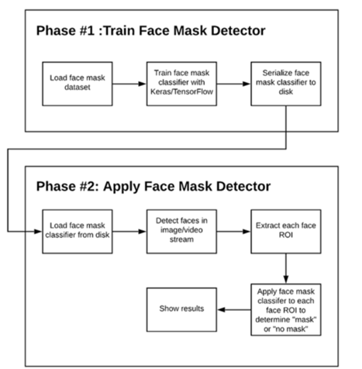**

**3.4 COMPONENTS USED   
  
1. Hardware Parts:** The hardware requirements for executing this model are: (a) Arduino Uno  
 (b) Servo Motor  
 (c) Jumper Wire  
 (d) USB Cable  
 (e) Mobile Phone **2. Software Parts:** The programming language used to develop this application is Python   
  
 and the IDE used is Jupyter Notebook.(a) Programming Language: Python  
 (b) Python IDE: Jupyter Notebook  
 (c) Framework: OpenCv ,Keras, Tenser Flow  
 (d) Technology Used : Web Server, Deep Learning  
  
Let’s Discuss about the **software part**.

**3.5 SYSTEM ARCHITECTURE**  
  
The architecture diagram shows the different processes that will be executed in the project and detailed design shows the complete working of each module that can be used for better understanding and executing the project to get the desired output.  
  
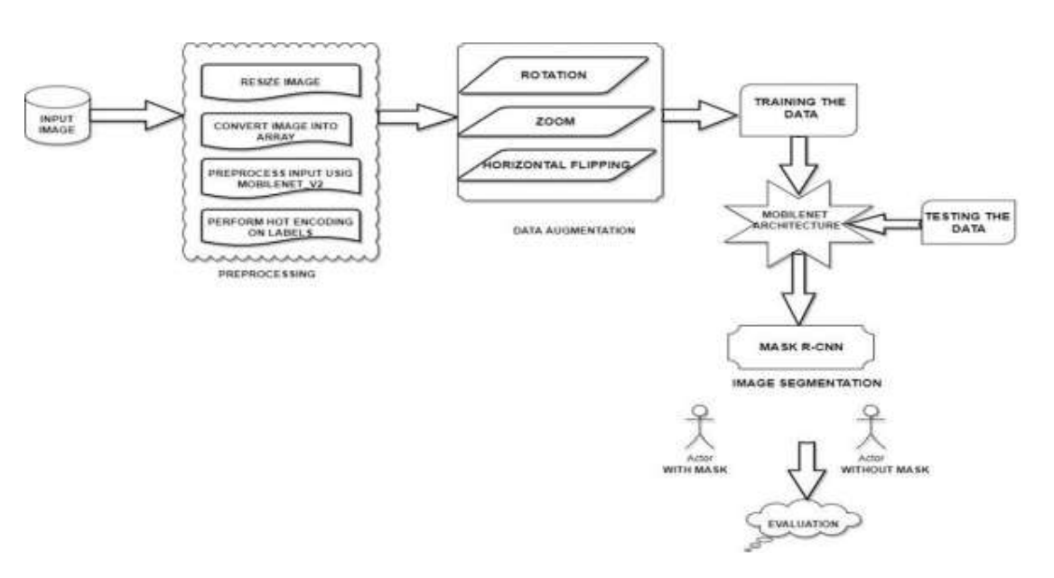

**Machine Learning Pipeline**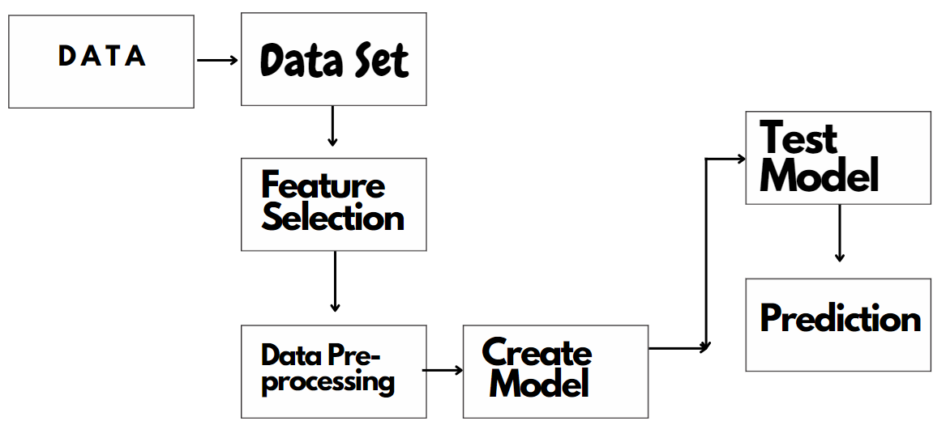

**3.6 MODULE DESCRIPTION** The system can be divided into six modules.   
  
 1. **Module 1:** Image Pre-processing   
 2. **Module 2:** Data Augmentation  
 3. **Module 3:** Model Training  
 4. **Module 4:** Testing the Model   
 5. **Module 5:** Image Segmentation using Mask R-CNN  
 6. **Module 6:** Implementing the Model in Opencv.  
  
**3.6.1 Input Image**  
  
 Dataset consists of two classes such as with mask and without mask.  
  
**3.6.2 Image Pre-Processing**Pre- processing is one of the common and initial steps followed in this project. The aim of pre- processing is to decrease unwanted distortions and improve image data along with enhancing a few important image features that will be used in further processing. In computer graphics and digital imaging, the term image scaling is used to define resizing of a digital image. In video technology, the term up scaling or resolution enhancement is used to define magnification of digital material. The graphic primitives in a vector graphic image can be scaled with no loss in image quality using geometric transformations. A new image of higher or lower number of pixels is expected while scaling a raster graphics image. A visible quality loss can be expected when decreasing the number of pixels. With reference to digital signal processing, one of the two-dimensional examples of sample rate conversion is 13 scaling of raster graphics which involves conversion of discrete signal from one sampling rate to another.   
  
The conversion of RGB to gray involves few processes. There are three algorithms in gimp image software for this. The method where the average of most prominent and least prominent colors used is called lightness method. The method where a simple average of three colors is used is called the average method. A more sophisticated method is the luminosity method. In this method, green is weighted heavily as it is more sensitive. The average is used in addition to weighted average for human perception. The conversion of gray to black and white happens in a binary image consisting of pixels having exactly one of two colors (black and white). In binary images, each pixel is stored as a single bit either 0 or 1. These images are often called as black-and white, monochromatic etc. The bitmap mode in Photoshop parlance is the same as a binary image. In digital image processing these images used as masks or thresholding and dithering.   
  
Only a few input/output devices like laser printers, fax machines and bit-level computer displays can handle bi-level images. A bitmap, a packed array of bits can be used to store a binary image. A 640x480 image would occupy 37.5Kb of storage. Fax machines and document management solutions prefer binary images because of their small size.

**3.6.3 Data Augmentation**A face mask detection system does not take input data, converts it randomly and returns both input and transformed data. The image data generator in keras uses the input image and transforms randomly into 14 transformed data. A collection of techniques introducing random jitters and perturbations and creating a new training sample from existing one is called data augmentation. The model’s generalizability is improved by using data augmentation. **3.6.4 Model Training**MobileNetV2 advances MobileNetV1 in areas like classification, object identification and semantic segmentation for mobile visual recognition. As part of tensor flow-Slim Image Classification Library, MobileNetV2 is available.  
  
MobileNetV2 is also available as TF-Hub modules, with pre-trained checkpoints.  
  
MobileNetV2 has two new architectural features:   
 ● linear bottlenecks between layers   
 ● shortcut connections between bottlenecks  
  
**Convolutional Neural Network**an artificial neural network that is optimized to process pixel data for image recognition and processing is called Convolutional Neural Network (CNN). The fundamental and building block of the computer vision task of image segmentation is the Convolutional Neural Network.● **Convolutional layer**: Use of filters and kernels help abstract the input image as a feature map.   
  
● **Pooling layer**: This layer is used to summarize the presence of features in patches of the feature map which helps in down sampling feature maps.  
  
 ● **Fully connected layer**: Every neuron in one layer is connected to every neuron in layer. 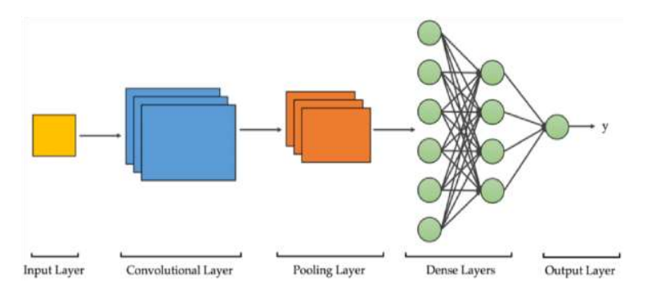  
 **3.6.5 Testing the Model  
  
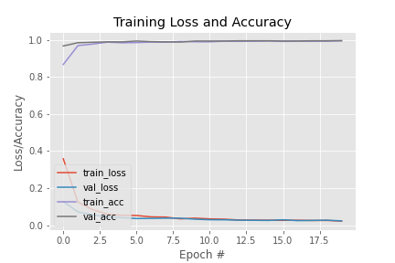  
  
Evaluation Metrics  
  
Accuracy**Accuracy is a measure of total correctly identified samples out of all the samples.  
  
It is defined as:   
  
**Accuracy = TP+TN/TP+FP+FN+TN**Where,   
  
 **True positive (TP) = correctly identified   
 False positive (FP) = incorrectly identified   
 True negative (TN) = correctly rejected   
 False negative (FN) = incorrectly rejected  
  
Precision:**   
Precision means to determine the number of positive class predictions that actually belong to the positive class.   
 **Precision = TP/TP+FP**  
**Recall:**  
Recall means to determine the number of positive class predictions made out of all positive samples in the dataset.   
 **Recall = TP/TP+FN  
  
F1-Score F1**-   
Score is the average mean of Precision and Recall.  
  
 **F1 Score = 2*(Recall * Precision) / (Recall + Precision)**   
  
**Macro Average**   
  
The method is straightforward. Just take the average of the precision and recall of the system on different sets. The Macro-average will be simply the average mean of Macro-average precision and macro-average recall.  
   
**Weighted Average**   
  
The F1 Scores are calculated for each label and then their average is weighted by support - which is the number of true instances for each label. It can result in an F1Score that is not between precision and recall.

**3.7 Algorithm - Face Mask Detection Using MobileNet V2**   
  
**Input:** Images   
  
**Output:** Face Mask Detected   
  
1. I(x) ←Input Images   
2. Cl← Convolutional Layer  
3. S (b) ←Size of Box   
4. F (m) ←Feature Map   
5. D← dimension of boxes   
6. F(C) ←Fully connected layer   
7. I(c) ←Change in Intensity of pixel   
8. L(r) ←Learning Rate, B(s) ←Batch size, E (p) ←Epochs   
9. A ←Threshold value   
10. Co ← Confidence   
11. T← No. of truth box 18   
12. B← Number of default boxes   
13. E B 2t×4 Truth boxes set T   
14. Class[l] ←Class labels set   
15. L (M) ←Load Model   
16. N← Total no. of class labels   
17. Obj ←Final Object   
 **3.8 Pseudocode for Face Mask Detection**   
  
1. Initialize the MobileNet V2 model   
2. Read the input Frame   
3. While true  
4. Initialize the L(r), B(s), E (p)   
5. Resize the I(x), height, and the width  
6. Load the base Model   
7. F (m) ← {Minimum Cl +Maximum I(c)}  
8. End for   
9. Calculate the blob  
10.For each Co, lens, S (b) do   
11.If lens > 0   
12. Width(W) = Xmin*Xmax   
13. Height(H) = Ymin*Ymax   
14.else 15.Resize the box with possible dimension   
16.else if   
17.else for   
18.Initialize the all objects   
19.X = cen [x] – w ÷2   
  
  
20.Y = cen[y] – h ÷2   
21.Assign x, y, w, h, Co, lens values  
 22.for i in indexes :  
23. for each i the truth box having class label class [1] do   
24. Class_id = max(scores)   
25. if confidence > 0   
26. Confidences.append(float(confidence))   
27. end if   
28. end for   
29.end for   
30.for I in class_ids :  
31. return label, confidence   
32.end for   
33.end for

**3.9 Implementing the Model**  
  
In Open Cv Finally the model is implemented using a webcam where the video is read by frame and resized as necessary. Then, the pre-processing function is called to get the result of people wearing a mask and not wearing a mask along with the accuracy in percentage.  
  
This way we have done our software part.  
Now, let’s discuss about **hardware part.**

**3.10 Hardware Part**In our project we have used the hardware part in which we have used Arduino board and servo motor that will detect the face mask and then if the mask will detected it will grant the permission to enter otherwise it will not detect the face mask the access will denied.  
  
We have connected our Arduino board with the laptop & then our servo motor is connected with the Arduino board.  
  
  
  
  
  
  
  
  
  
  
  
  
**3.10.1 Circuit Diagram**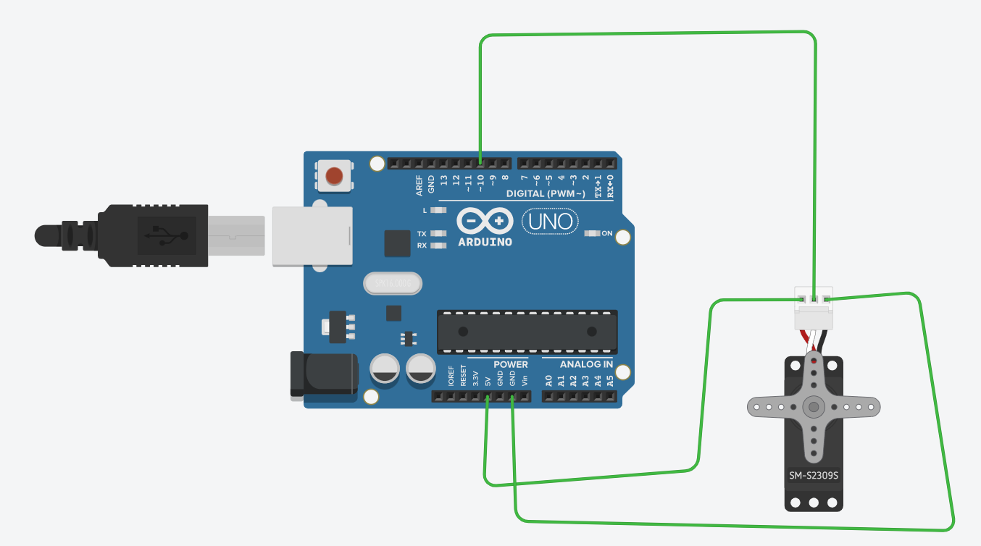

**3.11 Block Diagram**A block diagram is a graphical representation of a system – it provides a functional view of a system. Block diagrams give us a better understanding of a system’s functions and help create interconnections within it. They are used to describe hardware and software systems as well as to represent process.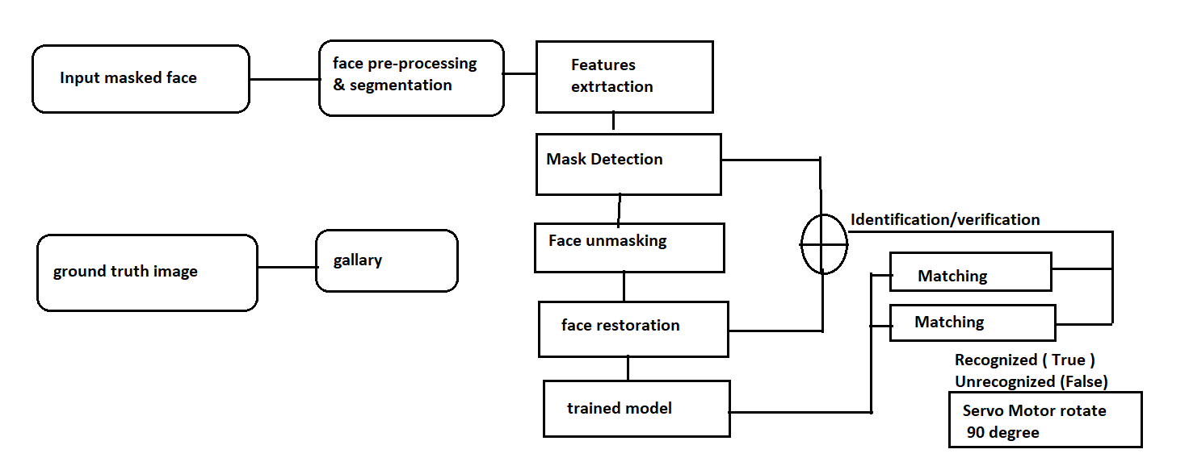

**Result  
4.1 Architecture Design**

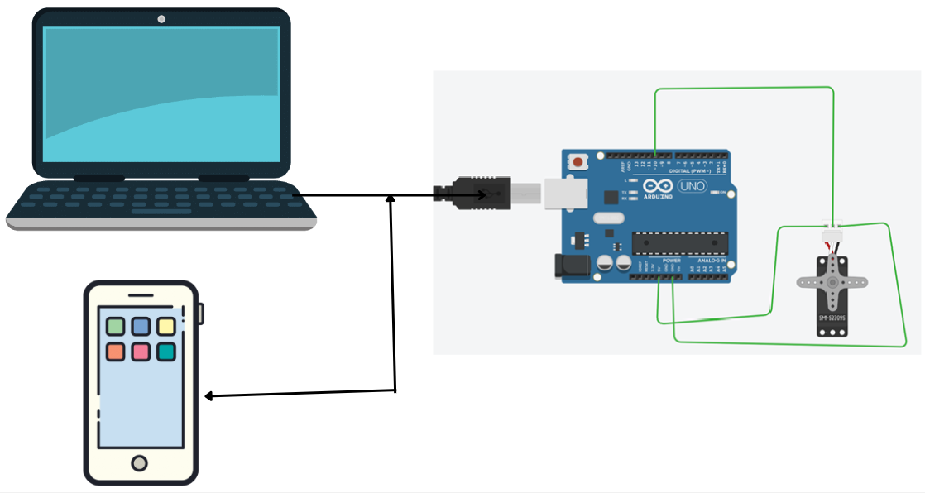  
Here, mobile camera & laptop camera is taking input as images.  
 **Output Images  
  
Importing the Face detection Program**   
  
After this, we intend to use it to detect if we are wearing a face mask using our PC’s webcam. For this, first, we need to implement face detection. In this, I am using the Haar Feature based Cascade Classifiers for detecting the features of the face.   
  
**Detecting the Faces with and without Masks**  
  
In the last step, we use the Open CV library to run an infinite loop to use our web camera in which we detect the face using the Cascade Classifier.

**1. With Mask  
  
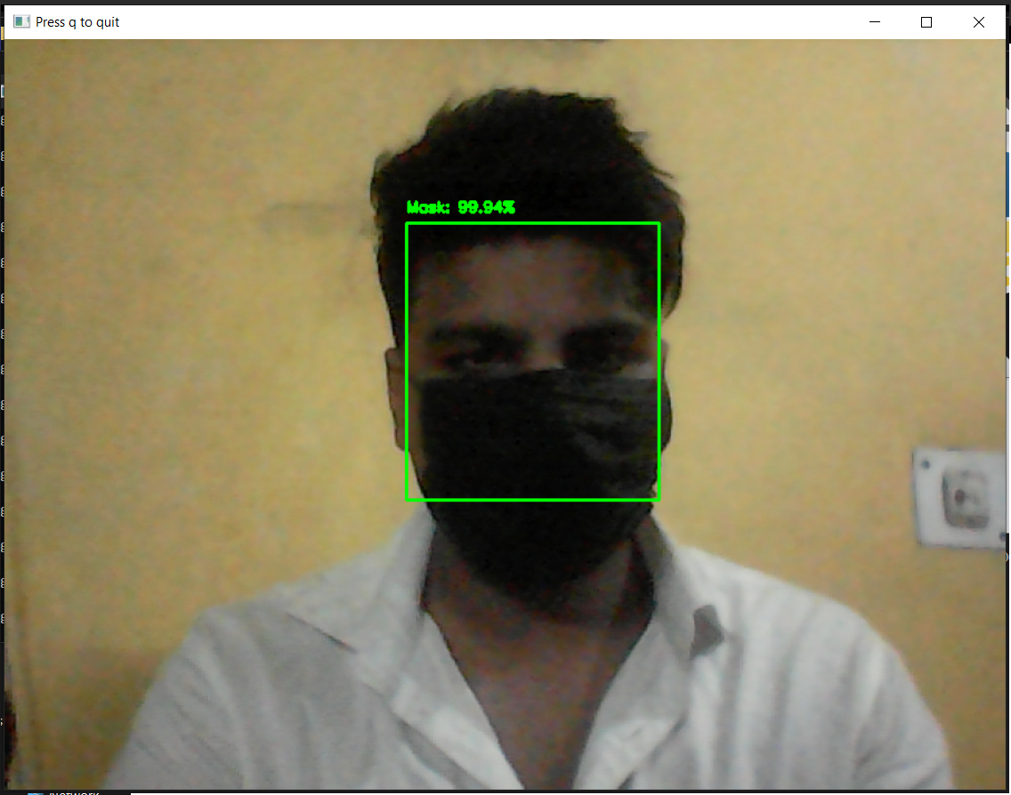**

**2. Without Mask  
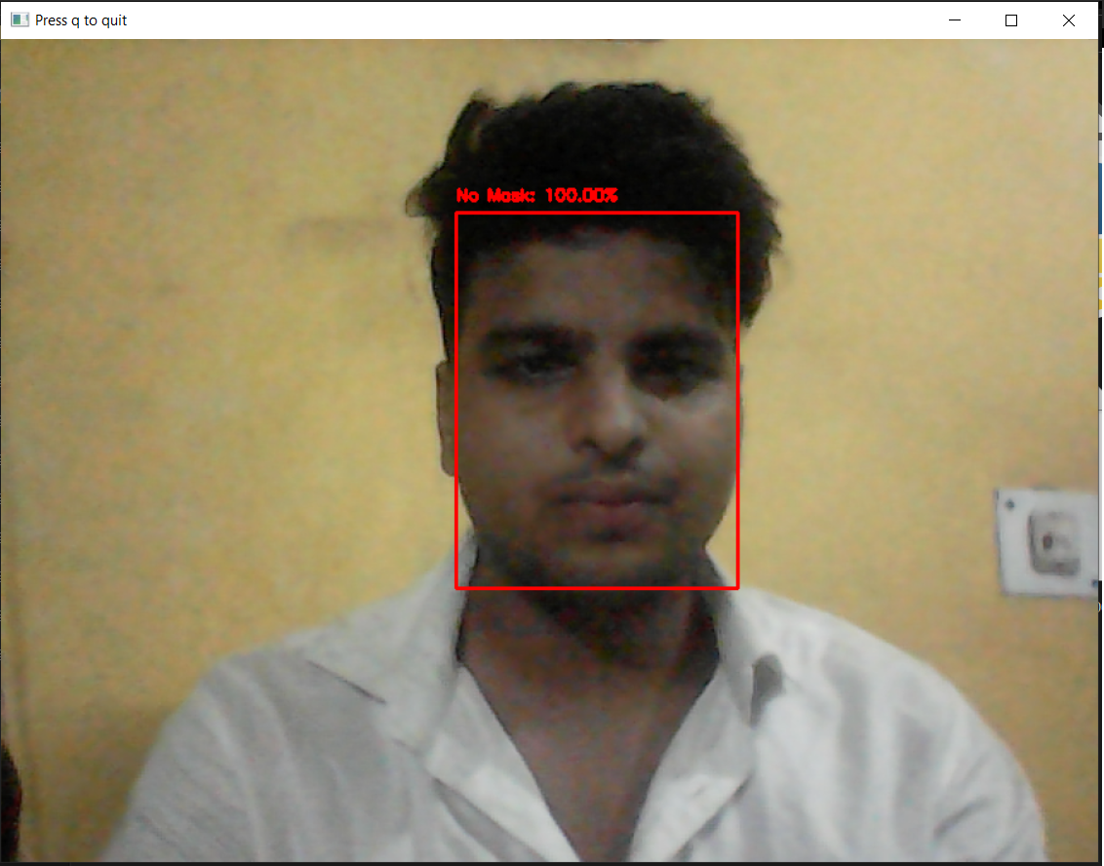  
  
ANALYSIS:**As visible from the above steps, our face mask detection technique first recognizes the person wearing the mask. If the person is wearing the mask, then a green display will be seen on the laptop screen signifying success and accordingly the servo motor will rotate by 90 degrees i.e the person is allowed to enter a designated place (shopping mall, hospital).If the person is not wearing the mask, then a red display will be seen on the laptop screen signifying rejection and the servo motor will stay still i.e the person is not allowed to enter the designated place.

**CONCLUSION:**The spread of Covid-19 is increasing every day in every corner of the world. This needs to be controlled to get back to our normal lives. While the specialists take care of the vaccine part, can help them by following the guidelines provided by WHO to remove/control the spread of this virus. The objective of the project is to recognize people wearing and not wearing masks using MobilenetV2. This algorithm is to convert an input image of a crowded place into our expected output which is identifying people not wearing a mask. Finally evaluating the numerical results.  
  
With the help of this project implemented in proper circumstances can help detect people not wearing masks. This could help health and sanitary officials to implement the WHO guidelines in a much better way. This project is tested in a webcam using the above discussed methods and the results are as expected. With wide use of this project in public gatherings and crowded localities, it will be easier to detect people violating the use of masks.

**FUTURE SCOPE:**Finally, the work opens interesting future directions for researchers. Firstly, the proposed technique can be integrated into any high-resolution video surveillance devices and not limited to mask detection only. Secondly, the model can be extended to detect facial landmarks with a facemask for biometric purposes.  
  
In this project, used MobilenetV2 algorithm and other deep learning techniques to identify people not wearing a mask. Tested this scenario using a webcam and an input dataset. In the future, this project can be used along with other AI methodologies and can be implemented in devices like Raspberry Pi, Autonomous drone systems etc., to improve the efficiency and reduce the detection time taken to detect people not wearing a mask.

**REFERENCE:**  
  
[1]J. Barabas, R. Zalman and M. Kochlan, ”Automated evaluation of COVID19 risk factors coupled with realtime, indoor, personal localization data for potential disease identification, prevention and smart quarantining,” 2020 43rd International Conference on Telecommunications and Signal Processing (TSP)  
  
[2]R. Moorthy H., V. Upadhya, V. V. Holla, S. S. Shetty and V. Tantry, ”CNN based Smart Surveillance System: A Smart IoT Application Post Covid-19 Era,” 2020 Fourth International Conference on I-SMAC (IoT in Social, Mobile, Analytics and Cloud)   
  
[3]K. Zhu, Z. Du, W. Li, D. Huang, Y. Wang and L. Chen, ”Discriminative Attention-based Convolutional Neural Network for 3D Facial Expression Recognition,”2018  
  
[4]M. M. Rahman, M. M. H. Manik, M. M. Islam, S.Mahmud and J. -H. Kim, ”An Automated System to Limit COVID-19 Using Facial Mask Detection in Smart City Network,” 2020 IEEE International IOT, Electronics and Mechatronics Conference  
  
[5]T. Meenpal, A. Balakrishnan and A. Verma, ”Facial Mask Detection using Semantic Segmentation,” 2019 4th International Conference on Computing, Communications and Security (ICCCS), Rome, Italy, 2019  
  
 [6]J.L.Amritha Varshini, J.L.Amrita Sree, Aathira Dineshan, T Anjali, O.D. Jayakumar, Abhilash Bharadwaj,”Face mask detection and recog-nition using an IoT enabled PDMSAg e-skin sensor that works incontact and non-contact modes”2019   
  
[7]Sheikh Rufsan Reza, Xishuang Dong, Lijun Qian”Robust Face MaskDetection using Deep Learning on IoT Devices”2018 International Conference on Design Innovations for 3Cs Compute Communicate Control  
  
[8]Talha Ikram, Abdullah Saeed, NoorUl Ayn, Muhammad Ali Tahir, RafiaMumtaz”A review of the prevalent ICT techniques used for COVID-19 SOP violation detection, 2018  
  
[9] Link :   
https://pyimagesearch.com/2020/05/04/covid-19-face-mask-detector-with-opencv-keras-tensorflow-and-deep-learning/